 Skeleton extension - Basics

The skeleton extension will allow you to create articulated objects like the human skeleton. This document is dedicated to the basics principles of the extension.

Table of contents

I. General presentation 1

II. The bones 2

A. The base bone (root) 2

B. The bone’s ends 2

III. Child bone 2

IV. Bones properties 3

A. Angle 3

B. Follow angle 4

C. Length 4

D. Offset 5

E. Images 6

F. Z-Order 6

G. Collision Mask 6

V. Conclusion 6

# General presentation

The skeleton extension provides an object named “Skeleton object”, actions, conditions and expressions which can act on it with the events.

The skeleton editor provides tools to create bones and animate them.

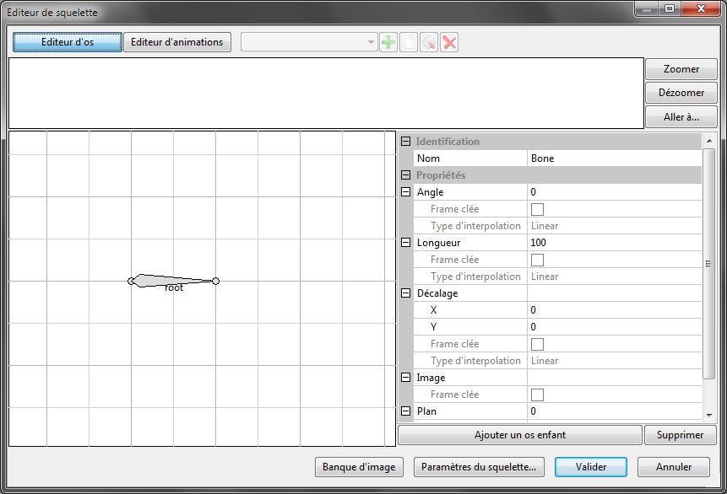

# The bones

## The base bone (root)

The left part of the editor shows the preview of the skeleton as thick lines. Each one represents a bone.

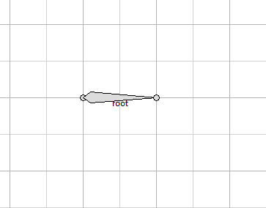

Here, the skeleton owns only one bone called “root”. This bone is the first bone of our skeleton and so it’s its base. Other bones will be connected to it.

## The bone’s ends

Each bone has two ends which are represented by a circle. These two ends don’t have the same role. They are differentiated by their name.



The head

The tail

The bone’s shape allows you to easily recognize the two ends.

# Child bone

By selecting the bone « root » and clicking on « Add a child bone », a dialog box asks you for the future name of the bone. It will be a child bone of “root”. In fact, it will be connected to the tail of its parent (“root”).

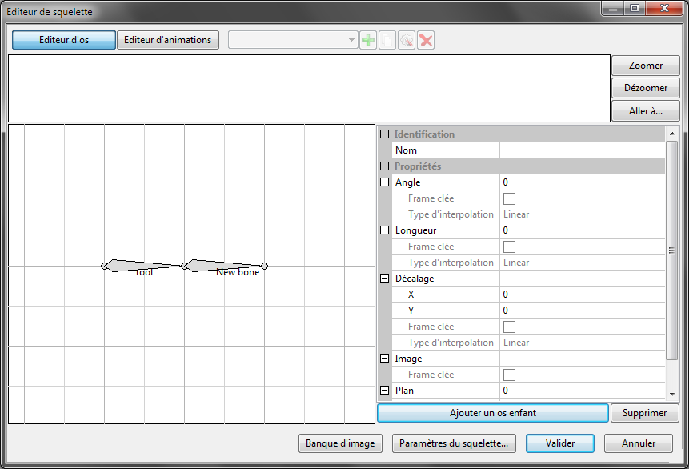

We will see that the child bones follow their parent’s tail (when we will change the parent’s length or angle).

*Note : A bone can have more than one child bone.*

Do the same thing with “New bone”, add a child bone to it. Give it a different name (in the example, it will be “New bone 2”). At the end, you would have probably something that look like this :

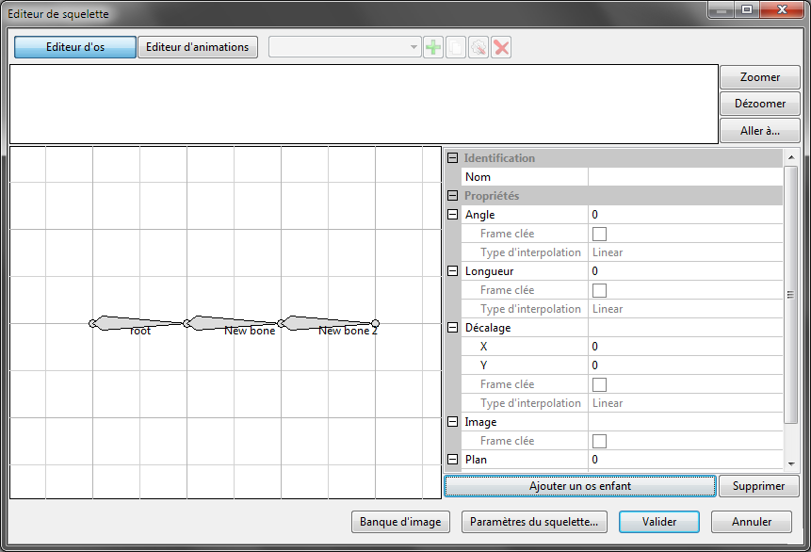

# Bones properties

The property grid on the right part of the editor can modify the different properties of the selected bone (like angle, length …).

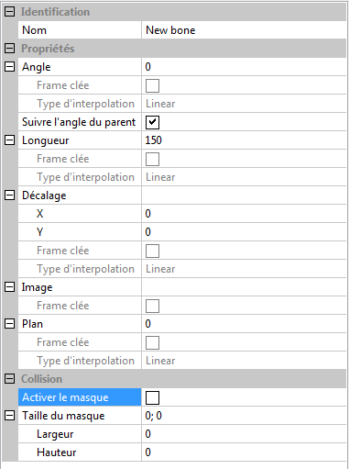

Select a bone and you can modify its properties, just by clicking in the grid cells. The properties named “key frame” and “interpolation kind” are useless if you don’t edit animations.

## Angle

By setting the angle of “New bone” to 40°, the bone rotates of 40° comparing to its parent. The result is shown in the picture below :

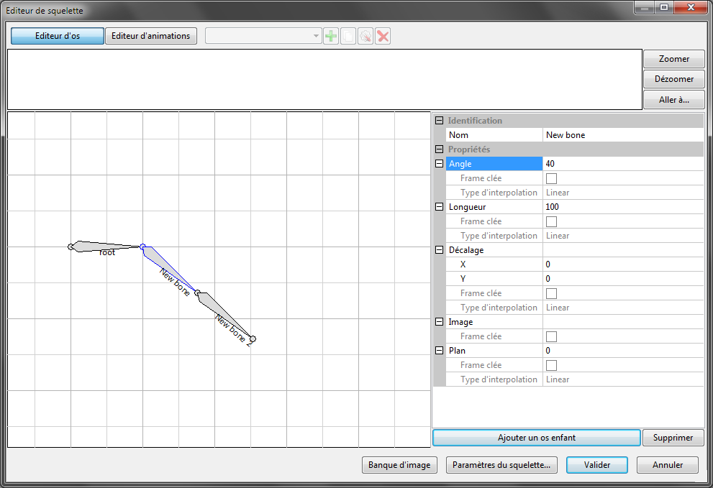

*Note : We can see that the child bone of “New bone” (“New bone 2”) is following its parent’s tail (and angle).*

By setting a 20° angle to the bone “New bone 2”, it rotates of 20° comparing to its parent which is “New bone” :

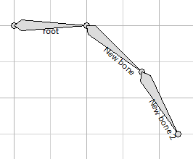

## Follow angle

This check box can disable the angle follow of a bone. The bone will conserve its angle, even if its parent rotates.

Disable the angle follow on “New bone 2”, and observe the result. “New bone 2” still have an angle of 20°, but not relatively to its parent.

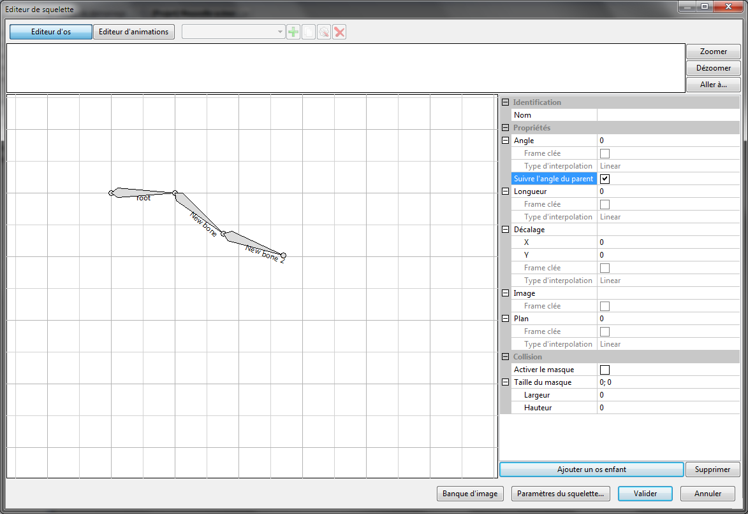

## Length

The length property can modify the length of a bone (as pixels). Select for example “New bone” and give it a length of 200. Observe the result :

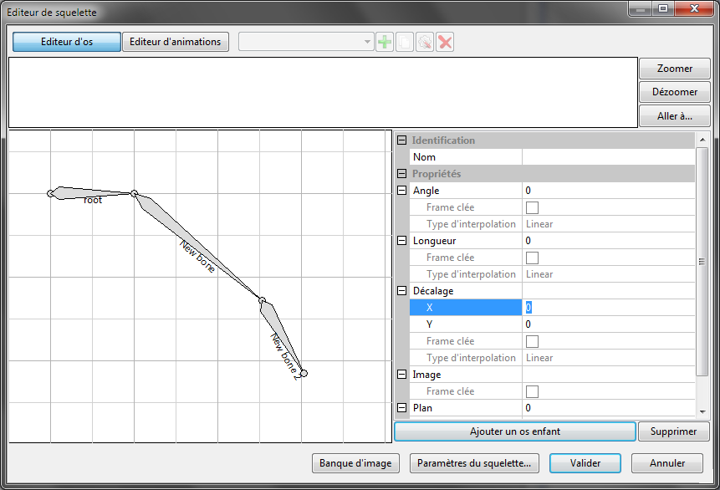

*Note : The child bone “New bone 2” stay connected to the tail of “New bone”.*

## Offset

The offset can add a space between a bone and its parent and conserve the connection between the two bones.

In the property grid, the two sub-properties “X” and “Y” can set this offset.

By setting an offset of 30 px on X and 15 px on Y to “New bone 2”, we obtain this :

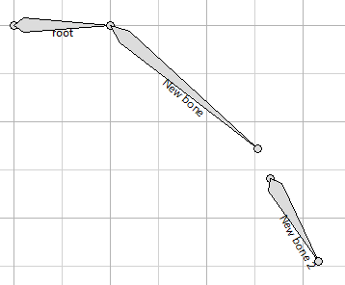

In fact, the offset is relative to the parent bone. The following diagram show how the X and Y coordinates are applied :



x

y

With this diagram, we can easily see that the offset is really 30 px on X and 15 px on Y.

## Images

This property allows you to set an image which will be placed automatically on the bone when the skeleton is shown in your game.

## Z-Order

The Z-order defines the sequence of the bone. A bone with a high z-order will be shown over other bones. A bone with a small z-order will be shown under other bones. The z-order of a bone is independent of its parent bone.

## Collision Mask

The collision mask allows you to add a rectangle as the hitbox of the bone. This can be useful to test if a bone or the skeleton collide another object in your game. You can enable or disable the mask and set its width and height.

# Conclusion

You are now able to produce some skeleton using the basics principle.